**High Level Design**

For

**Pharmacy Operations**

Date – 28th Feb 2024

Himanshu Kakkar

High-level documentation of pharmacy typically provides an overview of the field, including its role in healthcare, key concepts, and various aspects of pharmaceutical billing.

Here's a structured outline for such documentation:

1. **Patient Interaction**
   * Patient arrives at the pharmacy counter or interacts through other channels (phone, online).
2. **Prescription Intake**
   * Pharmacy staff receives the prescription from the patient or electronically from the prescriber.
3. **Verification and Triage**
   * Pharmacist or pharmacy technician verifies the prescription for accuracy, completeness, and legality.
   * Triage process to prioritize prescriptions based on urgency and patient needs.
4. **Patient Counseling**
   * Pharmacist provides counseling to the patient regarding medication instructions, potential side effects, and other relevant information.
5. **Dispensing**
   * Pharmacy staff selects, labels, and packages the medication according to the prescription.
   * Quality assurance checks to ensure accuracy and safety.
6. **Checkout and Payment**
   * Patient proceeds to the checkout counter to pay for the medication.
   * Processing insurance claims, if applicable.
7. **Medication Delivery**
   * Patient receives the medication at the pharmacy counter or through delivery services.
8. **Documentation and Record-Keeping**
   * Recording prescription information in the pharmacy system.
   * Compliance with legal and regulatory requirements for record-keeping.
9. **Inventory Management**
   * Monitoring medication stock levels.
   * Ordering and restocking medications as needed to maintain inventory levels.
   * Oversight of overall pharmacy operations, including staffing, scheduling, and resource allocation.
   * Continuous improvement initiatives to optimize workflow efficiency and patient satisfaction.
10. **Pharmacy Services**
    * Provision of additional services such as medication therapy management (MTM), immunizations, and health screenings.
    * Collaboration with other healthcare providers and community organizations to enhance patient care.
11. **Patient Follow-Up**

Follow-up with patients to assess medication adherence, monitor therapeutic outcomes, and address any concerns or questions.

Prescription

Intake

|

v

Verification

|

v

Dispensing

|

v

Quality Check

|

v

Counseling

|

v

Checkout

|

v

Medication

Pickup

|

v

Documentation

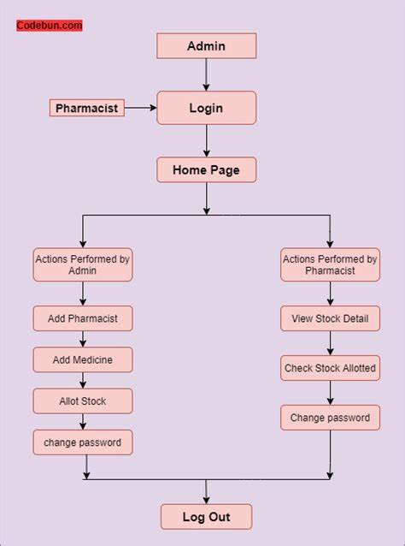

* This high-level flow diagram provides a visual representation of the main stages and interactions involved in pharmacy operations, from prescription

intake to patient follow-up. It serves as a useful reference for understanding the overall workflow within a pharmacy

* High-level documentation of pharmacy serves as a comprehensive overview of the profession, its role in healthcare, and its various aspects for both professionals and the general public.

Thank You